ThetaHealing®
Certified Instructors Mark and Maria Hubbuch
Call or email for more info: 239 910-6576 Mutu@aol.com
www.HarmonizingAmbientEnergy.com

Registration form

Name ______
Please print your name legibly, the way you would like it to appear on your certificate

Address ______

City __State _____________Zip __

Telephone Email: __________________________

Select Course: Theta Basic, Theta Advanced, Manifestation $ Abundance, Dig Deeper

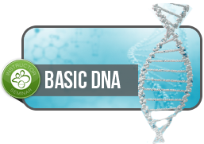

ThetaHealing® Basic DNA and ThetaHealing® Advanced
Each are three day classes
ThetaHealing Basic is prerequisite for Advanced
Manifesting and Abundance and Dig Deeper are two day classes
ThetaHealing Basic and Advanced are prerequisite for Manifesting and Dig Deeper
Cost per class:
$44 registration fee
$400 tuition

Make your check/money order payable to Harmonizing Ambient Energy, LLC
Mailing address –4051 Gulf Shore Blvd N, Box 503, Naples FL 34103
Or go on line to WWW.mkt.com/mutu
Or call with a credit card number, credit card fees will be applied.

(Must attend all 3 days to receive certificate and be permitted to advance to next level)

REFUND POLICY: Tuition is Refund if cancelled more than 24 hours prior to class start time. $44 Registration fee is nonrefundable. Attendance for partial day attendance is nonrefundable.

